Servo Lab Setup Instructions

Equipment – Power Supply

1. Set the Power supply to 12V, 0.55A.
2. Connect the power supply to the ‘Motors PWR’ ports on the Digilent Motor Control board:

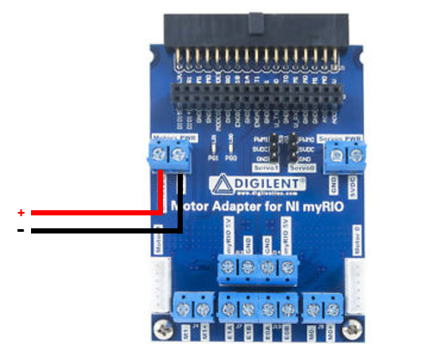

Figure 1

Equipment – myRIO (9-Pin DSUB Connector on Servo Equipment)

1. Connect the Digilent Motor Control board to myRIO Port A.
2. Connect the servo equipment to the myRIO according to figure 2:

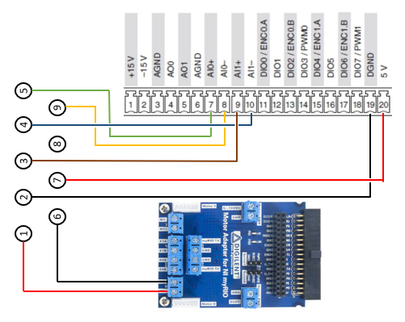

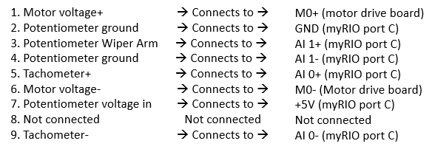

Figure 2

1. If necessary, test the hardware using the test project.

Equipment – myRIO (7-Pin Connector on Servo Equipment)

1. Connect the Digilent Motor Control board to myRIO Port A.
2. Connect the servo equipment to the myRIO according to figure 2:

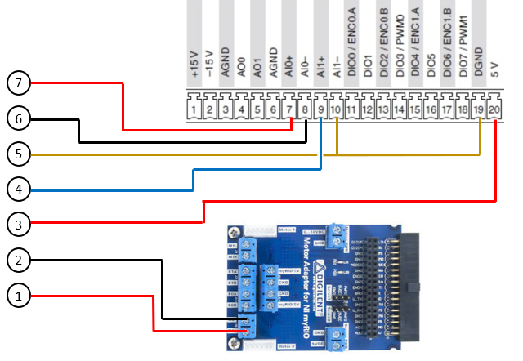

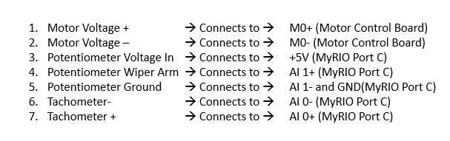

Figure 3

1. If necessary, test the hardware using the test project.

Software and running the experiment

1. Open the servo project
2. Right-click on the myRIO icon and select ‘connect’
3. Open ‘Experiment RT Servo.vi’.
4. Select inputs and then click the ‘Run arrow’. If prompted to save, select ‘save-all’ (note, this prompt will only happen during the first run of the experiment).
5. Repeat instruction 4 until satisfied.

Handling data

